**Strategy –**

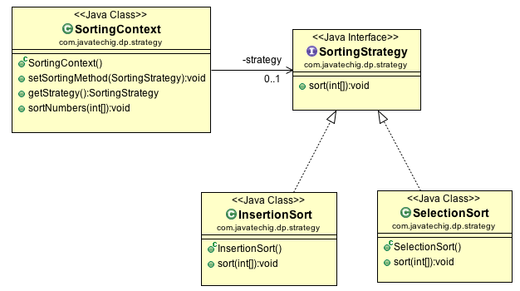

**Example 1 – Duck simulator from headfirst book**

**Strategy defines a family of algorithms, encapsulates each one, and makes them interchangeable. Strategy lets the algorithm vary independently from the client that uses it.**

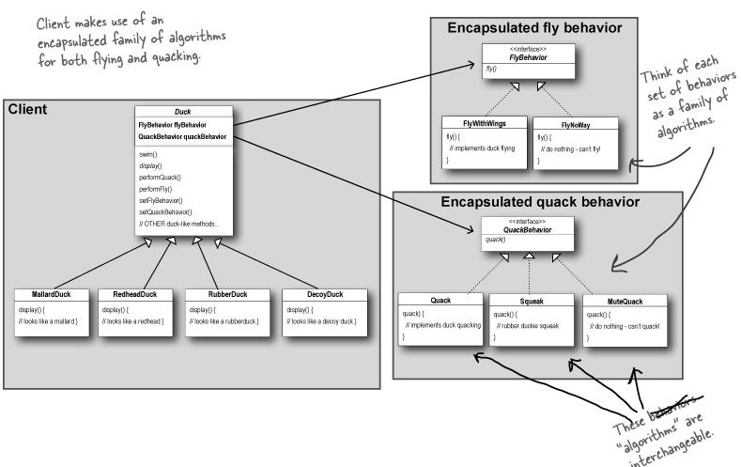

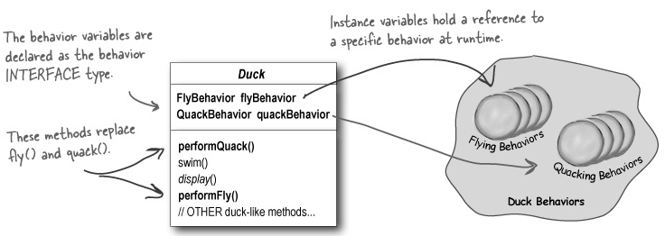

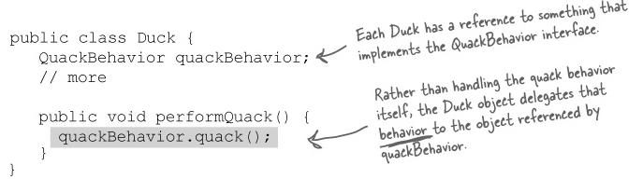

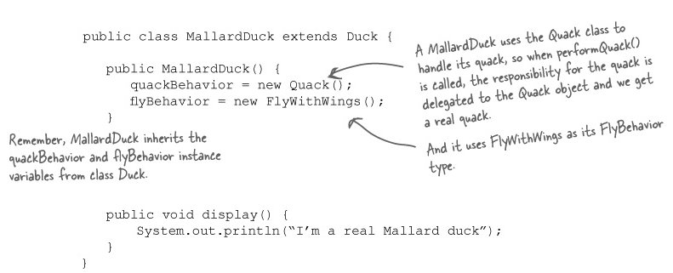

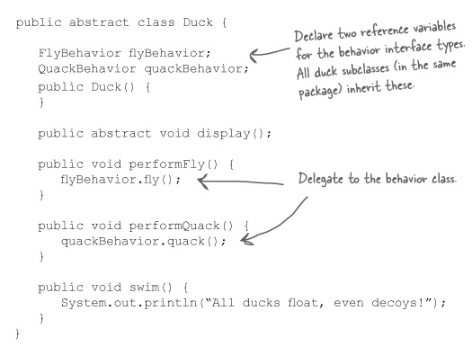

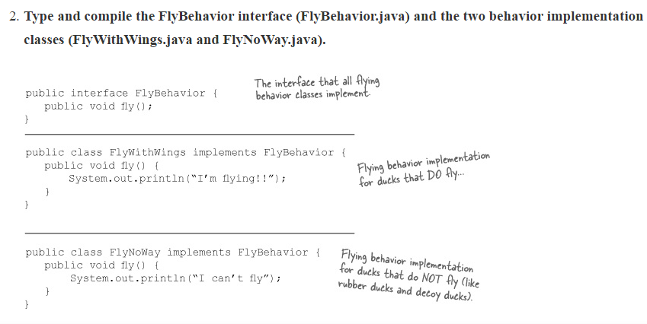

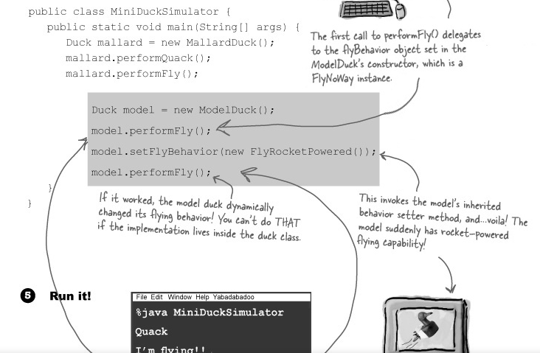

Practical example –

I have implemented in my project. I had a scenario where there are many different persons which were to be inserted/saved based on different algorithms.

1. PI – to be saved in contacts as well as PI table.
2. Drug Person – to be saved in contacts as well as drug table.
3. Visitors – to be saved in contacts only.

I have created a BusinessPerson interface and let this concrete classes implemented this. From service layer, I dynamically created different persons based on **FactoryPattern** and saved the person accordingly. BusinessPerson had abstract save () method and this method is implemented in different concrete person classes.

<http://stackoverflow.com/questions/370258/real-world-example-of-the-strategy-pattern>

Decorator –



